**HOME**

**Basic Design Document**

Version 1.0

Developed by Dao Quoc Trung

**Revision History**

|  |  |  |  |
| --- | --- | --- | --- |
| Name | Date | Reason to change | Version |
| Trung | 03/06/2021 | Initialize document | 1.0 |
|  |  |  |  |

**Table of Contents**

**Revision History 2**

1. **UI Design 4**
2. **UX Design 4**
3. **Architecture Design 4**
4. **Process Design 5**
   1. Open Home app 5
   2. Open 1 app (Media icon, Media widget) 6
   3. Close 1 apps (back to home) 7
   4. Flick left/right 7
   5. Re-order Apps 8
   6. climate send information to widget 9
   7. media send information to widget 10
5. **UI Design**

UI is presented in the UI Design Document.pdf

1. **UX Design**

UX is presented in the UI Design Document.pdf

1. **Architecture Design**

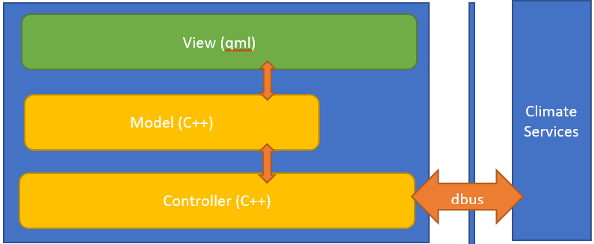

Figure 1: Architecture layout

View(qml): This is the management screen, the elements are built with qml, and the resources of the build screen

Model: As the data building for managing the state of the interface from C ++, it is the place to show the data for the construction of the state of the screen.

Controller: As part of processing, program control, and responsible for connecting to the 3rd services (specifically here is climate services)

The architecture built for the program is built on the Model View architecture

Figure 2: model view Architecture

Data: xml contains application information in the system

Model: The class stores the reading application list from the xml file

View: QML displays the list application

1. **Process Design**
   1. Open Home app

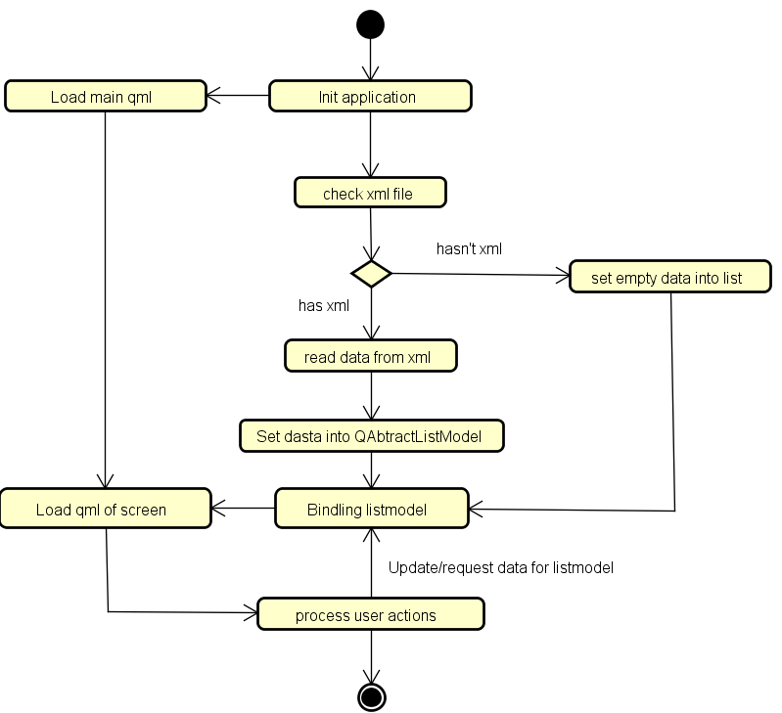

Figure 3: Open Home app

Step to start the home program:

* Step 1: Create engine object of QQmlApplicationEngine
* Step 2: Create appsModel object of ApplicationsModel
* Step 3,4: Create xmlReader object of XmlReader with the value passed as the path to the xml file and appsModel object
* Step 5: Read the xml file
* Step 6: Parse information from xml to ApplicationsModel object
* Step 7: Binding appsModel to QML by settingContextProperty
* Step 8: Start the QML engine by loading the url of the main qml file
  1. Open 1 app (Media Icon, Media Widget

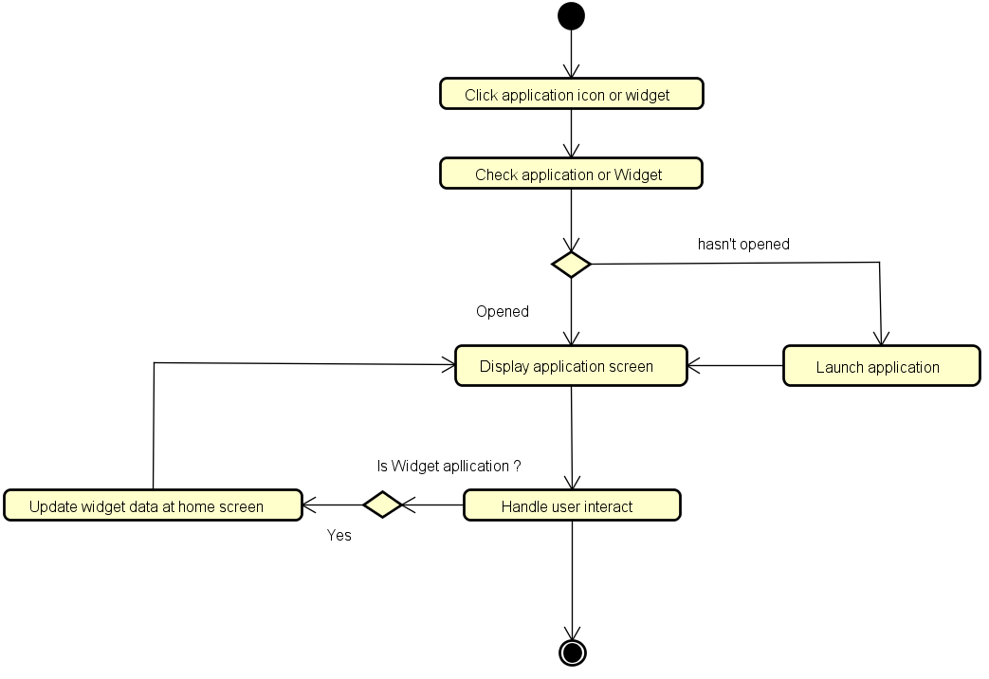

Figure 4: Open 1 app

Step to open 1 app:

* Step 1: Click application icon or widget icon
* Step 2: Start and run Application
* Step 3: Display Application
  1. Close 1 apps (back to home)

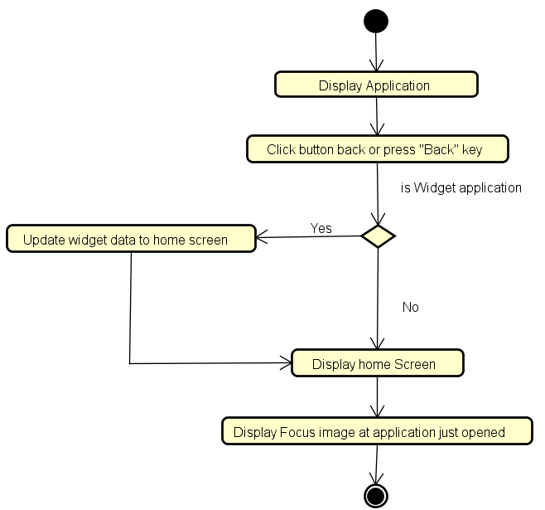

Figure 5: Close 1 apps(back to home)

Step to close 1 app:

* Step 1: Click Back Button
* Step 2: Send data from app or widget to Home screen
* Step 3: Display Home screen
  1. Flick Left/Right

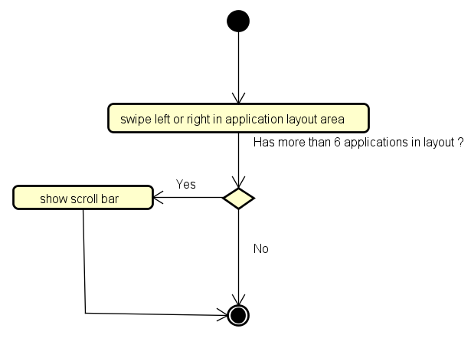

Figure 6: Flick Left/Right

Step to Flick Left/Right:

* Step 1: Swipe left or right in application listView area
* Step 2: Show scroll bar
  1. Re-order Apps

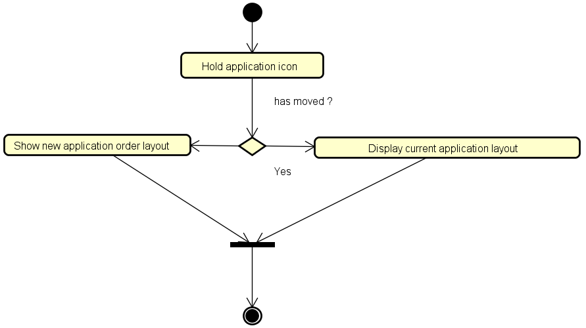

Figure 7: Re-order Apps

Step to Re-order Apps:

* Step 1: Hold app icon
* Step 2: Move app icon to new position
* Step 3: Update new layout by listView
* Step 4: Display new application order layout
  1. climate send information to widget

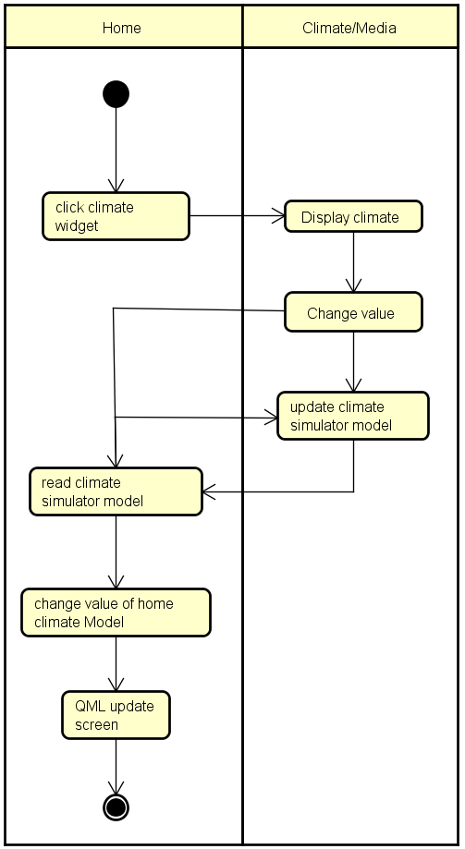

Figure 8: climate send information to widget

Step to climate send information to widget:

* Step 1: Click climate widget from widget layout in home screen
* Step 2: Run and Display climate screen
* Step 3: Change value in climate screen
* Step 4: climate screen qml file update instance of climate simulator object model Step 5: climate screen send signal to Home screen qml file
* Step 6: Home screen qml file get signal and read data from climate simulator object model
* Step 8: Home screen qml update home climate model
* Step 9: QML update Home screen
  1. media send information to widget

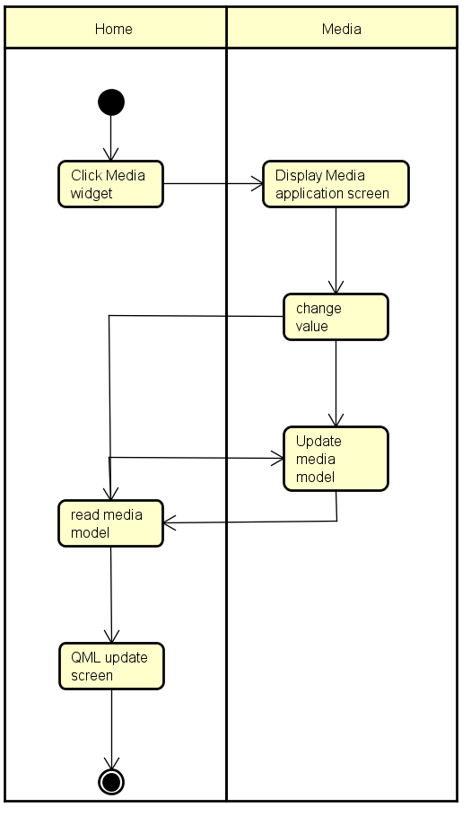

Figure 9: media send information to widget

Step to media send information to widget:

* Step 1: Click media widget from widget layout in home screen
* Step 2: Run and Display media screen
* Step 3: Change value in meida screen
* Step 4: update instance of QObject model
* Step 5: send signal to Home screen qml file
* Step 6: Home screen qml file get the singal
* Step 7: Home screen read data from Qbject model
* Step 8: QML update Home screen